DATA ANALYSIS INTERNSHIP – DAY 4 REPORT
Organization: Top Tech Developers
Topic Covered: Creating Data Visualization Charts for EDA Insights (Home Assignment)
On Day 4 of the internship, different data visualization techniques were used to analyze the Student Performance dataset graphically. Visualization played an important role in understanding student performance patterns, grade distribution, and subject-wise analysis more clearly during Exploratory Data Analysis (EDA).

1. Grade Distribution Analysis
Grade distribution analysis was performed to understand how students were categorized based on their academic performance.
Charts were created to represent the number of students in each grade category.
Grade Categories
- Excellent
- Good
- Average
Observation
- Most students belonged to the Good category.
- Students with higher study hours and higher subject scores achieved Excellent grades.
- Lower performance levels resulted in Average grades.

2. Subject-wise Performance Analysis
Subject-wise performance analysis was performed to compare student marks across different subjects using graphical representation.
Subjects Analyzed
- Mathematics
- History
- Physics
- Chemistry
- Biology
- English
- Geography
Observation
- Students showed better performance in some science subjects such as Physics and Chemistry.
- Balanced subject scores improved overall academic performance.
- Comparison charts helped identify subject strengths and weaknesses.

3. Study Hours Analysis
Visualization techniques were used to analyze the relationship between weekly self-study hours and student academic performance.
Analyzed Areas
- Weekly self-study hours
- Grade performance
- Subject score improvement
Observation
- Students with higher study hours generally achieved better grades.
- Regular study habits improved student performance.
- Study time showed a positive relationship with academic achievement.

4. Charts Created
The following visualization charts were created to represent the dataset clearly:
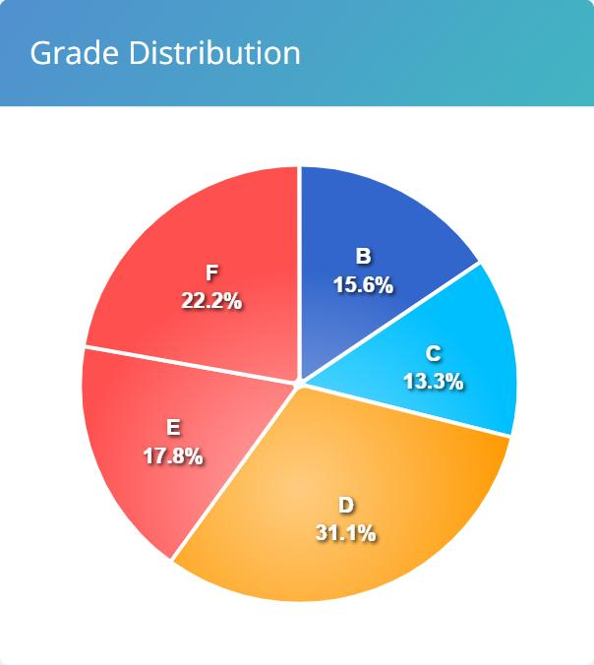
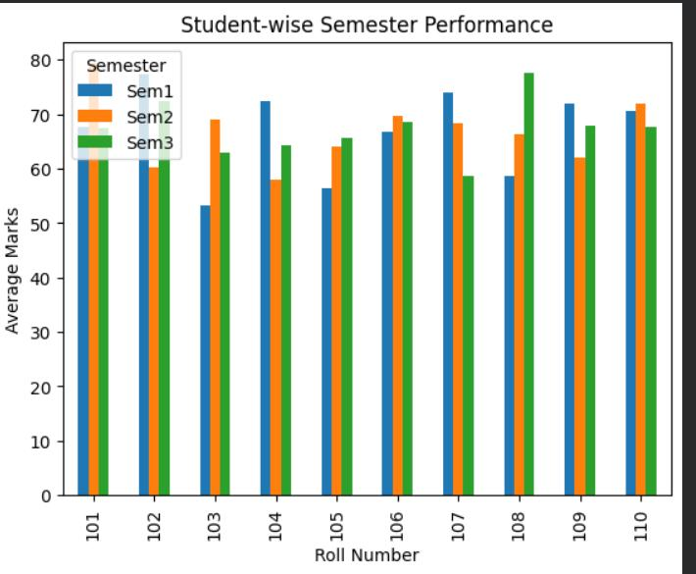
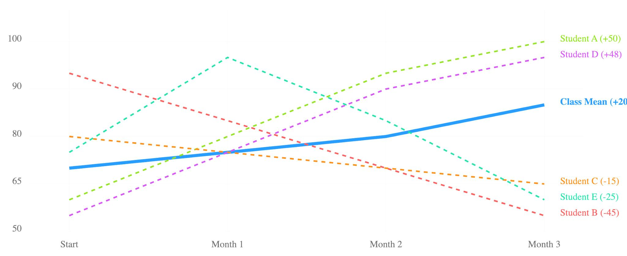
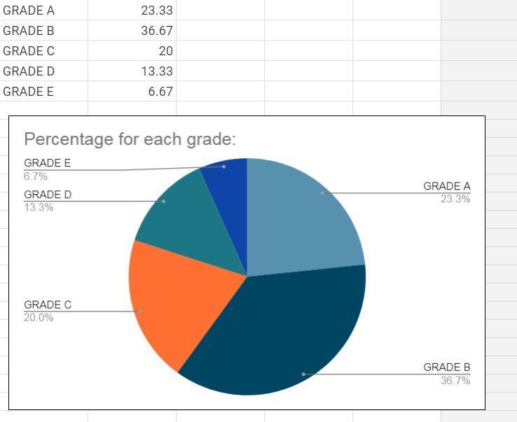
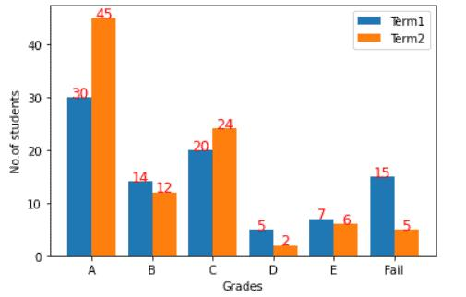
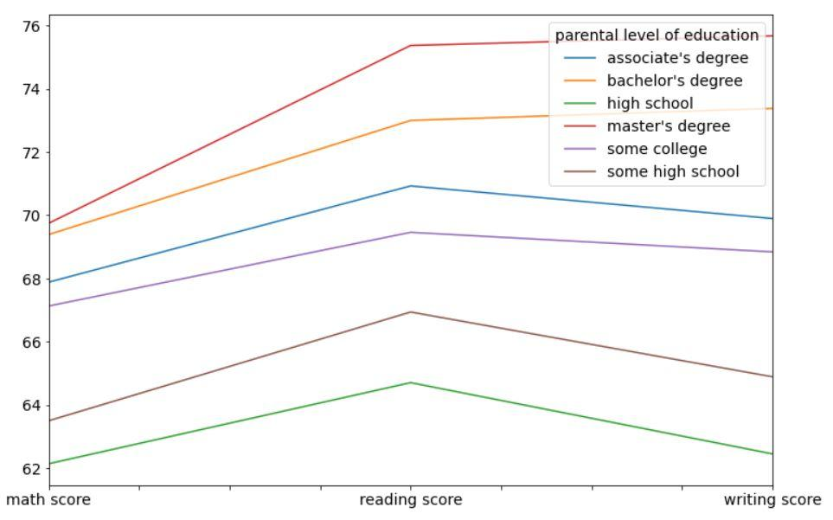
Charts Used
- Bar Chart
- Line Chart
- Pie Chart
Purpose of Charts
- Compare subject scores
- Analyze grade distribution
- Understand performance patterns
- Represent student data visually
Observation
- Graphical representation makes dataset analysis easier and more understandable.
- Visualization helps identify trends and comparisons quickly.
- Charts provide a simple way to interpret large datasets.

5. EDA Insights
Important insights identified from the dataset include:
- Higher subject scores improved overall grades.
- Study hours played an important role in academic performance.
- Balanced scores across all subjects resulted in better student performance.
- Visual analysis made it easier to identify hidden trends in the dataset.

Technologies Used
- Python
- Pandas
- Matplotlib
- NumPy
- Microsoft Excel
- Data Visualization
- Exploratory Data Analysis (EDA)

Learning Outcome
On Day 4, I learned how data visualization helps in analyzing datasets more effectively.
I understood:
- how to create charts for dataset analysis
- how to represent grade distribution graphically
- how to compare subject scores using charts
- how to analyze the relationship between study hours and performance
- how visualizations help identify trends and patterns
- how charts simplify Exploratory Data Analysis

Conclusion
The Day 4 internship session helped me understand the practical use of Data Visualization in Exploratory Data Analysis. I created different charts such as bar charts, line charts, and pie charts to analyze student grades, study hours, and subject-wise performance.
By using visualization techniques, I gained a clear understanding of how graphical representations make dataset analysis easier, improve comparison, and help identify important patterns in real-world educational data.

